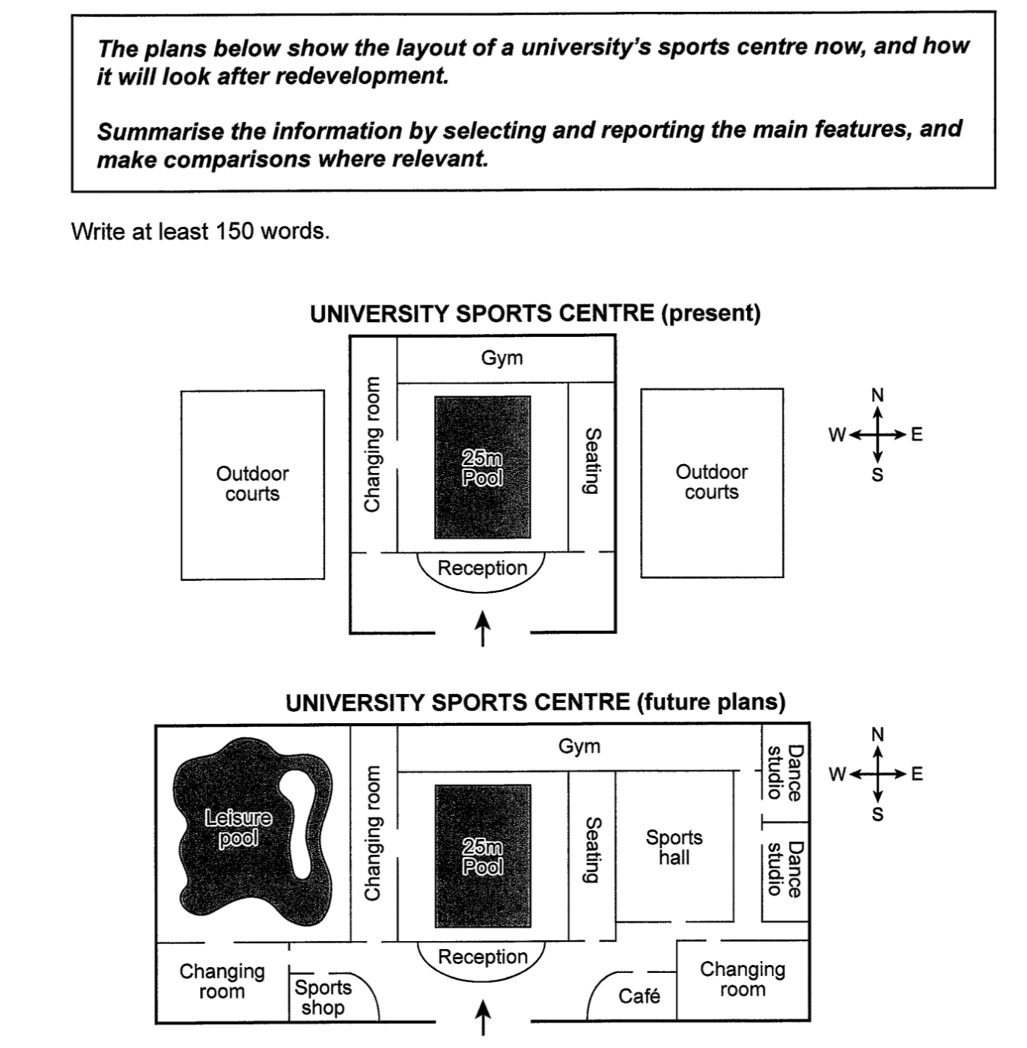

The diagrams show how a sports centre at a university will change in the future.

Overall, although outdoor courts will be removed, the sports centre will expand significantly with new infrastructures including a leisure pool and a sports hall.

Now, there is a 25m swimming pool situated in the centre of the building, which is equipped with a changing room and a seating area. On the northern side of the swimming pool, there is a gym, whereas a reception is located on the southern side of the pool. Outside the building, two outdoor courts are positioned on the western and the eastern sides respectively.

According to the plans, outdoor courts will be demolished and the building will become a fully enclosed facility. In the west wing of the complex, a leisure pool will be built, whereas a sports hall will be developed in the east wing, both of which will be provided with a large changing room. While the swimming pool will remain unchanged, the gym will be extended and attached to two new dance studios in the northeastern corner, and the reception area is going to become larger, including a sports shop and a café.

(~196 words)

The diagrams show how a sports centre at a university will change in the future.

Overall, although outdoor courts will be removed, the sports centre will expand significantly with new infrastructures including a leisure pool and a sports hall.

Currently, within the main building, there is a reception in the south, behind which exists a 25m swimming pool, with a changing room and a seating area on its both sides. A gym stands behind the pool. Outside the main building, two outdoor courts are situated in the west and the east respectively.

According to the plans, the sports center will become a fully enclosed block. Although the original swimming pool will remain unchanged, two outdoor courts will be demolished to make way for a leisure pool in the west and a sports hall with two dance studios in the east. Two new changing rooms will be provided to these facilities respectively. The gym will be extended, so will be the reception, which will accommodate a sports shop and a café.

(~170 words)

The diagrams show how a sports centre at a university will change in the future.

Overall, although outdoor courts will be removed, the sports centre will expand significantly with new infrastructures including a leisure pool and a sports hall.

体育中心将大幅扩建，并附带增加新的基础设施，包括一个游泳池和一个体育馆。
学会灵活使用with, including。

SAMPLE 1: Now, there is a 25m swimming pool situated in the centre of the building, which is equipped with a changing room and a seating area (游泳池周边的更衣间、座椅，都是游泳池的配套设施，可以用be equipped with, 或直接用with). On the northern side of the swimming pool, there is a gym, whereas a reception is located on the southern side of the pool (一北一南，体现对比，两句之间可以用while/whereas连接). Outside the building, two outdoor courts are positioned on the western and the eastern sides respectively.

SAMPLE 2: Currently, within the main building, there is a reception in the south, behind which exists a 25m swimming pool, with a changing room and a seating area on its both sides. A gym stands behind the pool (stands = be located / be situated). Outside the main building, two outdoor courts are situated in the west and the east respectively.

SAMPLE 1: According to the plans, outdoor counts will be demolished and the building will become a fully enclosed facility. In the west wing of the complex (complex替换building), a leisure pool will be built, whereas a sports hall will be developed in the east wing, both of which will be provided with a large changing room. While the swimming pool will remain unchanged, the gym will be extended and attached to two new dance studios in the northeastern corner, and the reception area is going to become larger, including a sports shop and a café.

SAMPLE 2: According to the plans, the sports center will become a fully-enclosed block. Although the original swimming pool will remain unchanged, two outdoor courts will be demolished to make way for a leisure pool in the west, a sports hall with two dance studios in the east. Two new changing rooms will be provided to these facilities. The gym will be extended, so will be the reception, which will include a sports shop in the west and a café in the east.

